**Z.O.O Report**

Group: ITEC Pantry

Jiaziruo Sun (101121503)

Shuheng Wang (101140312)

Xiaoman Lin (101137873)

Xinyin Zhang (101098426)

**Table of Content**

**Table of Content**

1.0 What are we creating and Why 1

2.0 Project Content

2,1 Entities with subclass 2

2.2 Attribute 3

2.3 ER & EER diagram 6

2.4 Normalization 7

2.5 Website 10

3.0 Conclusion 11

4.0 Contribution 12

Reference 13

# 1.0 What are we creating? Why?

We are going to create a database for the largest zoo in Canada, Toronto Zoo. It has more than 5000 animals representing over 500 species. The animals are mainly classified into seven regions: Indo-Malaya, Africa, Americas, Tundra Trek, Australasia, Eurasia, and the Canadian Domain.[1] It opens many interesting activities like wild camping and scenic safari drive through. Visitors can have an immersive wild trip there.

For such a mass zoo, it’s important to manage everything in perfect order. They need to track animals, employees, and events to avoid occasional incidents. Our project Z.O.O will help them group and store all the information in a database, updating personnel changes and animals’ state and make it faster and easier to find an archive.

# 2.0 Project Content

## **2.1 Entities (with subclass)**

* Employee
  + Trainer
  + Security
  + Technician
  + Cleaner
* Animal
  + Africa
  + Americas
  + Australasia
  + Canada Domain
  + Indo-Malaya
* Department
* Service
  + Camping
  + Gift shop
  + Scenic Safari Drive thru
  + Walking route
* Visitor
* Payment method
  + Cash
  + Credit
  + Debit
* Ticket (weak entity)

## **2.2 Attributes\***

*subclasses are marked in blue.

* Employee
  + Name (composite)
    - First name
    - Middle name
    - Last name
  + Birthday (composite)
    - Year
    - Month
    - Day
  + Address (composite)
    - Street name
    - Street number
    - Postal code
  + Contact information (composite)
    - Email
    - Phone number
  + Salary
  + Age(derived)
  + Gender
  + ID (key)
  + Job_type
* Technician
  + DeptinCharge
* Trainer
  + AnimalinCharge
* Security
  + AreainCharge
* Cleaner
  + CleanArea
* Animal
  + Name
  + Age
  + Sex
  + Species
  + Preference (multivalued and composite)
    - Diet
    - Environment
  + Domain
  + Quantity(derived)
  + ID (key)
* Africa
  + AfricanCountry
* Americas
  + AmericanCountry
* Australasia
  + Aus_Area
* Canada_Domain
  + province
* Indo-Malaya
  + IM_Area
* Department
  + Department code (key)
  + Phone
* Service
  + Opening hours (multivalued)
  + Phone number
  + Service Num (key)
* Camping
  + Camping_area
* Walking_Route
  + Route_name
* Gift_shop
  + location
* Scenic_Safari_Drive_thru
  + drive_route
* Visitor
  + Name (composite)
    - First name
    - Middle name
    - Last name
  + ID (key)
  + Age (derived)
* Payment method
* Credit
  + Credit_id
* Cash
  + amount
* Debit
  + Debit_id
* Ticket
  + Price
  + Overdue date (composite)
    - Day
    - Month
    - Year
  + Type
  + Ticket ID (key)

## **2.3 ER Diagram and EER Diagram**

**2.4 Normalization**

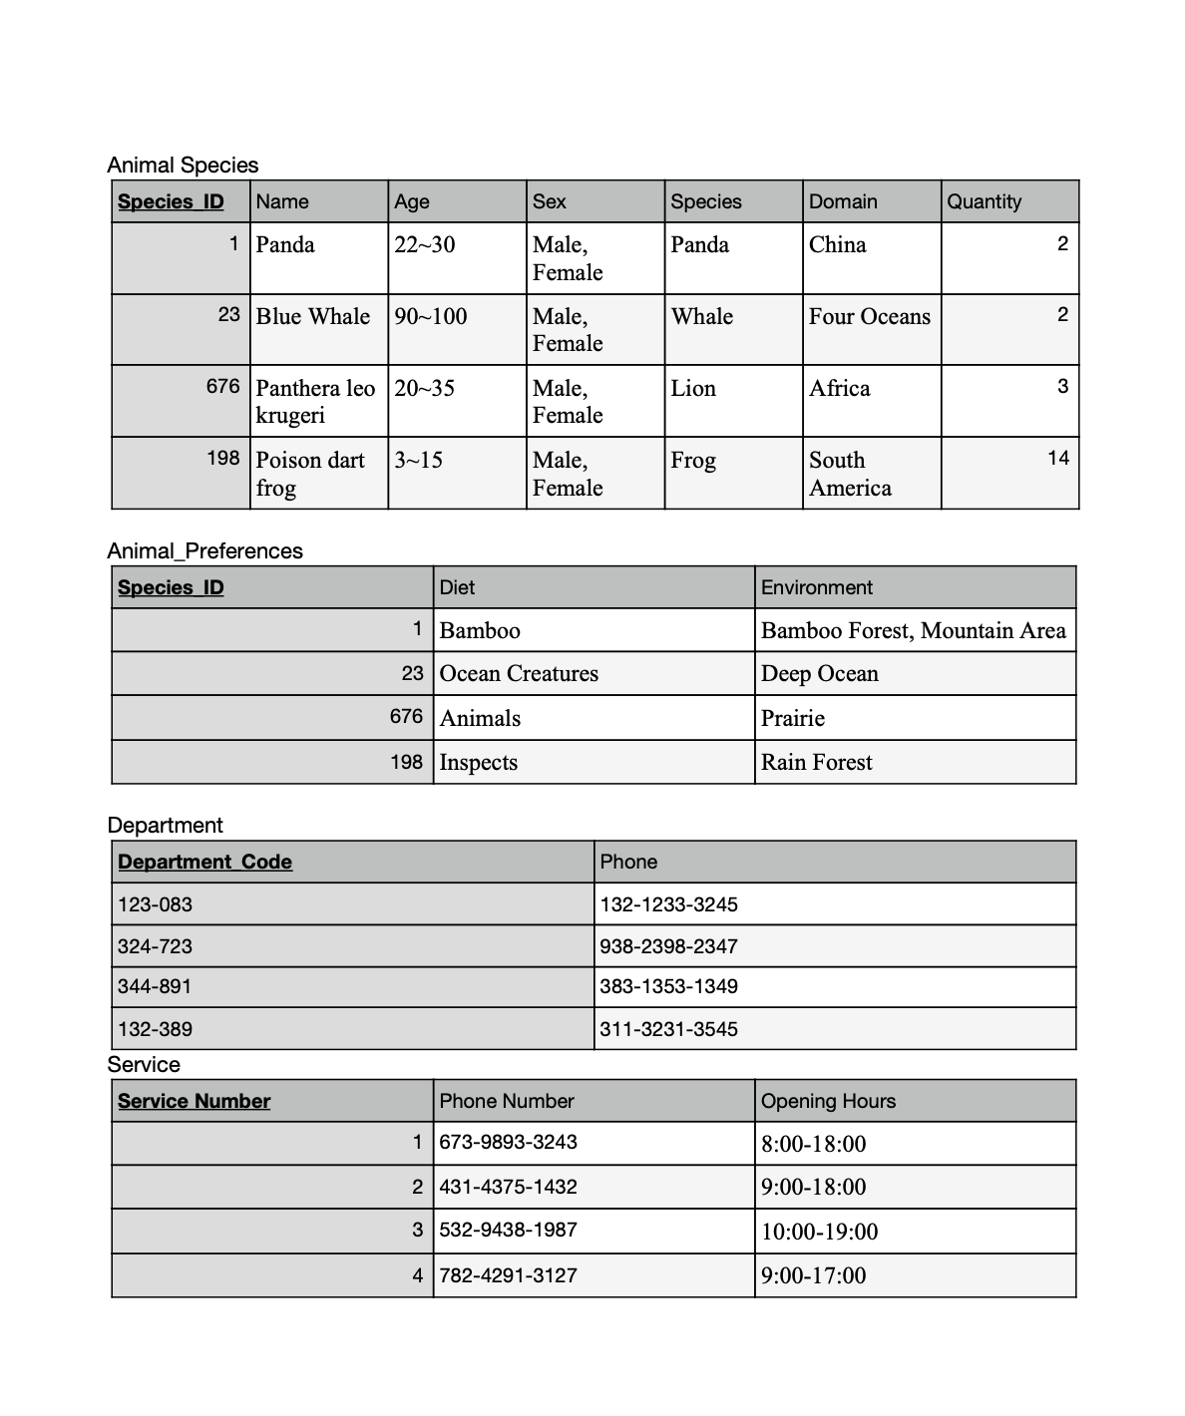

**2.5 Website**

Navigation tree:

Website link: <http://students.bitdegree.ca/~xinyinzhang/part4/Login.php>

User account for testing:

First name: Luisa

Last name: Dunken

ID: 0000_3147

Animal information for testing:

Animal ID: 1

Animal Species: Panda Animal Domain: China

Animal Name: Panda

# 3.0 Conclusion

Our team is aiming to establish a database of Toronto Zoo focusing on its information about the animals, employees, and other necessary functional data to help build a more efficient managing system. The database will provide the access of tracking information in three aspects: the animal archive, the employee archive and the daily visitor turnover.

Looking back at the whole project, we faced many problems in each part, and we tried hard to learn how to fix them. While making ER and EER diagrams, we had many entities that didn’t have an attribute, so it became meaningless to draw subclass relationship. To fix that, we modified our entities to make sure that they all had attributes. Since we separated our highly detailed user information into different tables, it would be heavy work if we gave values to each of them. we decided to only insert values into the table which need to be shown on the page. But it created many null values in other tables. The biggest problems we encountered so far is debugging. We often make unconscious tiny mistakes like missing quotation marks or using different variable names while these took us so much time to debug. We appreciate teamwork because wo can check each other’s code and find the bugs we didn’t realize.

In the future projects, we need to be careful with the consistency of naming variables, using of punctuation marks and write code neatly. We should avoid putting too much null values in the database because it affects joining tables.

# 4.0 Contribution

Jiaziruo Sun

* Examine ER and EER diagrams
* Design physical database (map binary 1:N relationship types, map binary M:N relationship types.)
* Create SQL files for normalized tables
* Create update and create record pages
* Write reflection

Shuheng Wang

* Conclude the project proposal
* Examine ER and EER diagrams
* Design physical database (map regular entity types, map weak entity types, map binary 1:1 relation types)
* Create filled and normalized tables
* Create navigation tree for websites
* Create join table pages and view specific record pages
* Write reflection

Xiaoman Lin

* List entities
* Draw the ER and EER diagrams
* Design physical database (map multivalued attributes, map specialization)
* Create webpages (List, ER and EER, Physical Database, Normalization)
* Create delete record pages and multimedia pages
* Write reflection

Xinyin Zhang:

* Create the report document and presentation
* Examine ER and EER diagrams
* Draw physical database design and demonstrate design process
* Build the website skeleton
* Create webpages (Home, About Us, Login)
* Create SQL tables and make CSS
* Create login/register pages
* Write report and presentation PPT

# Reference

“Toronto Zoo: Home.” Accessed September 25, 2020. <http://www.torontozoo.com/>

1. “Toronto Zoo: Home,” accessed September 25, 2020, <http://www.torontozoo.com/>.